# How to Write A Research Paper Abstract? A Beginner guide with examples.

The prospect of writing a research paper abstract from scratch can be overwhelming. It must capture the core of your work and provide readers with an idea about why it’s significant or pertinent.

In this article, we'll discuss what makes a good abstract for a research paper, and how to craft one that captures the essence of the work and gets its significance across. We'll give you some models to follow so you can begin working on your own right away.

## What is a research paper abstract? what is its importance?

The main ideas and significant outcomes of a research paper are succinctly summarized in a research paper abstract. A research paper abstract is included at the beginning and should include all relevant terms, concepts, and questions that were addressed in the paper as well as any deductions and implications drawn from it.

The purpose of an abstract is to enable readers to quickly comprehend the subject of a paper without having to read the entire document. This can be especially helpful for readers who are not conversant with the area being discussed or do not have time to read through every detail.

Anyone reading your abstract will have a clear understanding of what was investigated, how it was carried out, and why it matters because an effective abstract should successfully review all aspects of your work.

## Types of abstracts for a research paper

Abstracts are sum-ups of long research papers and can be used to give the reader an outline of your paper. There are a variety of formats that could work for your research paper, depending on the specifics of your topic and your intended audience. Here are the types of research paper abstracts;

### Informative abstract:

An informative abstract has more profound information than a descriptive abstract, it gives additional information about what is contained in each heading and subheading within your research paper. You should use this abstract when you want to give an explanation of complex topics in your research paper without necessitating readers to read through your entire project.

### Descriptive abstract:

A descriptive summary gives a brief summary that defines the main ideas covered within the paper. These summaries should be short, but they should also have enough information for readers to understand what is being talked about in the full text.

### Critical abstract:

A critical abstract criticizes data from different useful sources and gives a conclusion regarding that evaluation. This abstract is useful when you want to give a deduction that resulted from a comparison of two or more studies.

### Reflective Abstract:

This abstract gives evidence from personal experience. It does not rely on published sources. this makes it relatable to readers who do not understand technical terms and vocabulary in your discipline. A reflective abstract is more relatable and easier to write.

## Parts of an abstract for a research paper

An abstract should cover these important five sections

* Introduction
* Objective
* Methods
* Outcomes
* Conclusion

The structure of your research paper abstract relies heavily on the area of study that the author is a part of. Typically, they are arranged into four fundamental components:

* Background of your research project
* Aims/Objectives
* Methods and approach
* Results

**The Background** section should provide the context of the research and explain how it links to previous literature or research on that topic.

**The Aims** provide a succinct overview of what was expected to be achieved through performing the study. This could be addressing a question or trying out a notion.

**The Methods and approach** show how data were collected and analyzed in order to answer any questions given at the commencement of this project or further investigate a specific issue area selected during your literature review process.

**Results** show the main outcomes from your work such as findings from statistical analysis or qualitative insights gained from interviews with participants for example.

To ensure an abstract serves its objective and contains the relevant components of your report, there are various recommendations you may follow while creating one:

* Keep it brief (preferably no longer than 300 words)
* Use clear language that can be understood by readers who may not have knowledge about the subject matter
* Avoid using technical terminology unless necessary and structure each component around one central point in order to make sure ideas flow.

## Tips for writing a good abstract

* An abstract is meant to be a quick and easy way to understand what the paper is about.
* It requires that you detail not only your goals but also your techniques, findings, and overall findings and conclusions.
* Abstracts range in length from about 150 words to about 250 words, depending on the journal or publication they're being submitted to.
* Briefly outline the study technique used, followed by a summary of the most important findings and a discussion of the implications for future research and policy changes.
* In the end, briefly summarize their key points.
* A successful abstract will assist readers in rapidly discerning whether they intend to read or not based on its clarity.

## Example of a research paper abstract

Example 1: This study presents a literature review on the topic of the effects of student-teacher relationships on students' academic performance.

Higher academic achievement, better attendance and behavior, reduced dropout rates, a more pleasant school climate, and greater enthusiasm to learn are all linked to positive teacher-student connections, according to the research.

There is, however, less scientific information on how these connections are generated in the classroom or how they might be strengthened over time.

Further research is needed to evaluate the causal effects between the quality of teacher-student relationships and academic outcomes. This includes both qualitative studies of students' subjective perceptions of teacher-student interactions and quantitative studies using large longitudinal data sets.

### Example 2:

Research about the reasons for increasing economic homogamy among spouses

Gonalons-Pons, Pilar, and Christine R. Schwartz. “Trends in Economic Homogamy: Changes in Assortative Mating or the Division of Labor in Marriage?” *Demography*, vol. 54, no. 3, 2017, pp. 985-1005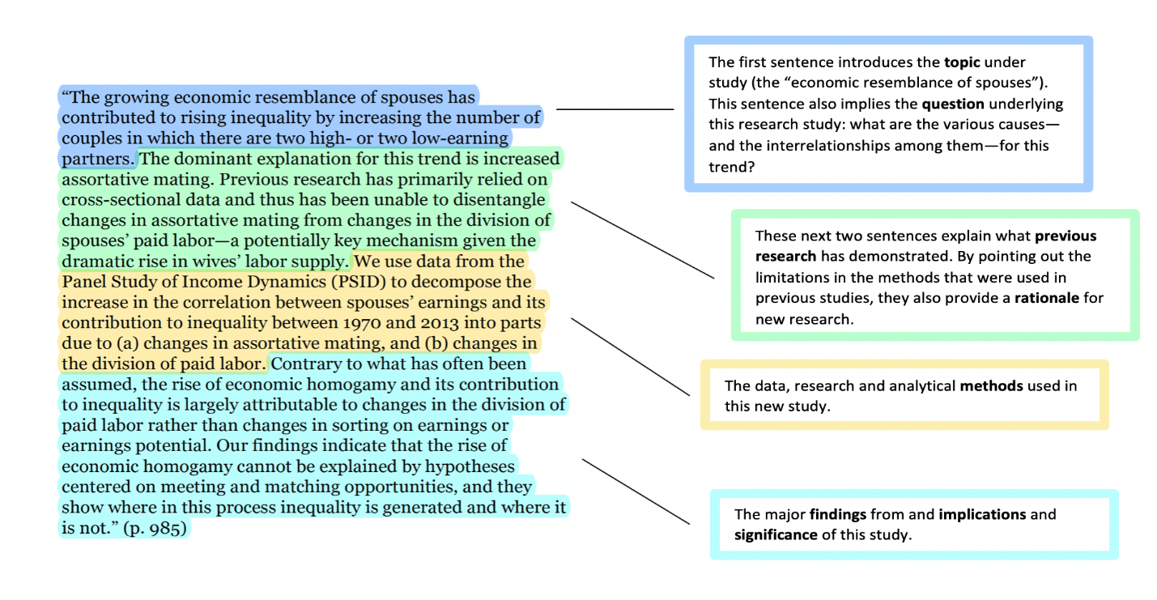

## Conclusion

In conclusion, it can be hard to write a research paper abstract. But it's important to keep in mind that the purpose of an abstract is to give a summary of your paper's main points. To do this task well, you need to include all the important information without going off-topic or giving too much detail. Also, make sure to use clear, concise language so that people can quickly and correctly understand what you mean. If you need research paper writing help feel free to get a quote and get expert help.